LABORATORY EXERCISE 4

ADVANCED DATA INTEGRITY, GRADEBOOK MANAGEMENT & ROLE-BASED DASHBOARDS

Learning Objectives
By the end of this laboratory exercise, students should be able to:
- To design and implement a gradebook system within an existing database schema, incorporating new entities and complex relationships.
- To understand and apply advanced data integrity constraints, including composite primary keys and CHECK constraints, to enforce critical business rules.
- To create and manage database views to simplify complex queries and provide customized data perspectives for different user roles.
- To develop role-specific dashboards in a VB.NET application that display relevant, aggregated information and allow for data manipulation based on user permissions.

Prerequisite student experiences and knowledge
Students are expected to have completed and understood the concepts from Laboratory Exercise 3, including:
- Creating tables with PRIMARY KEY, FOREIGN KEY, and UNIQUE constraints.
- Implementing one-to-one and one-to-many relationships.
- Resolving many-to-many relationships using a junction table.
- Building a basic VB.NET Windows Forms application with a login system and role-based redirection.

Background
This lab extends the academic management system from Lab 3 by adding a core feature: a gradebook. You will model how grades are assigned to students for their enrolled courses. This introduces a ternary relationship, connecting Students, Courses, and a new AssignmentTypes table through the Grades table. Furthermore, you will learn to use database Views to create pre-defined, simplified queries for your application, enhancing performance and security. Finally, you will build upon the existing VB.NET application to create functional dashboards for Teachers and Students.
Materials/Resources
- dbGate
- Personal Computer with Internet Access
- XAMPP/WAMP/LAMP server installed
- Visual Studio(VB.Net Development)
Laboratory Activity
Using your DB_Lastname database, perform the following steps.
- Create the AssignmentTypes Table
This table standardizes the types of assessments used in courses.
  - AssignmentTypes Table Schema
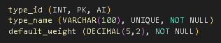
- Create the Grades Table
This table records a grade for a specific student, in a specific course, for a specific assignment type. The composite primary key enforces that a student can only have one grade per assignment type per course.
  - Grades Table Schema
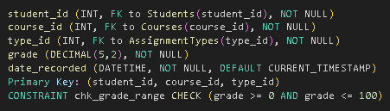
- Create Database Views for Role-Based Data Access
Views act as virtual tables, simplifying complex queries for the application.
  - Create a StudentGradeSummary View:
This view will be used by the Student dashboard. It shows students their own grades in a readable format.
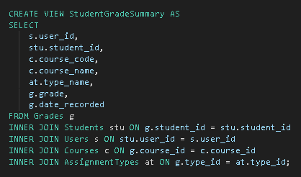
  - Create a TeacherCourseOverview View
This view will be used by the Teacher dashboard. It provides an aggregated summary of grades for the courses they teach.
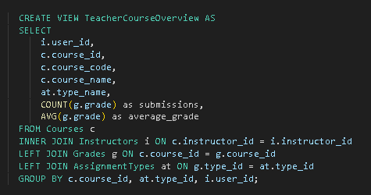
- VB.NET Application Implementation Tasks
  - Enhance the Teacher Dashboard
    - Create a new form TeacherDashboard.vb.
    - Upon login, a teacher should be redirected here.
    - The form should:
      - Use the TeacherCourseOverview view to display a list of courses taught by the logged-in teacher, including the average grade and number of submissions for each assignment type.
      - Allow the teacher to select a course and an assignment type to enter or update a student's grade.
        - Involves an INSERT or UPDATE on the Grades table.
  - Create a Student Dashboard
    - Create a new form StudentDashboard.vb.
    - Upon login, a student should be redirected here.
    - The form should:
      - Use the StudentGradeSummary view to display a list of all the students' grades across all their enrolled courses.
      - Calculate and display the student's current overall average per course.
  - Enhance the Admin Management Form
    - Add functionality for the admin to:
      - View and manage the AssignmentTypes table
        - Add
        - Edit
        - Delete types.
      - View all grades across the system
        - A read-only grid linked to the Grades table with student and course names.
- Create the Enrollments Junction Table
- This table resolves the Many-to-Many relationship between Students and Courses. Its composite primary key ensures a student cannot be enrolled in the same course more than once.
  - Enrollments Table Schema:
    - enrollment_id (INT, PK, AI)
      - Optional surrogate key, often easier for ORMs
    - student_id (INT, FK to Students(student_id), NOT NULL)
    - course_id (INT, FK to Courses(course_id), NOT NULL)
    - enrollment_date (DATETIME, NOT NULL, DEFAULT CURRENT_TIMESTAMP)
    - CONSTRAINT unique_enrollment UNIQUE (student_id, course_id)
      - Essential business rule

Output / Results
- Screenshot of Updated Database Schema
  - Show the new tables: AssignmentTypes, Grades.
  - Show the new Views: StudentGradeSummary, TeacherCourseOverview.
  - The Foreign Keys tab for the Grades table should show its three foreign key relationships.
- Screenshot of Updated Database EER Diagram
  - The diagram must now include the AssignmentTypes and Grades tables, clearly showing:
    - The many-to-one relationships from Grades to Students, Courses, and AssignmentTypes.
    - The composite primary key in the Grades table.
- Screenshots of Enhanced VB.NET Application
  - The new Teacher Dashboard showing the course overview and the interface for entering a grade.
  - The new Student Dashboard showing the student's personal grade summary and course averages.
  - The enhanced Admin Form showing the management interface for AssignmentTypes.

QUESTIONS:
- The Grades table uses a composite primary key (student_id, course_id, type_id). What specific business rule does this enforce, and why is it critical for a gradebook system?
The composite primary key (student_id, course_id, type_id) ensures that a student can have only one grade for a specific assignment type in a specific course. For example, a student can have one Quiz grade in Database Systems, but the same Quiz grade cannot be entered twice for that student and course. This is important because it prevents duplicate grades and keeps the gradebook accurate and organized.
- Explain the purpose of the CHECK constraint chk_grade_range in the Grades table. What would happen if someone tried to insert a grade of 105 or -10?
The CHECK constraint chk_grade_range makes sure that the grade entered is within the allowed range, such as 0 to 100. If someone tries to enter a grade of 105 or -10, the database will reject it because those values are outside the valid range. In simple terms, the CHECK constraint acts like a guard that prevents incorrect grades from being saved in the database.
- How does using a Database View improve the application compared to writing the full SQL query directly in the VB.NET code?
A Database View makes the application easier to develop because it stores a complex SQL query in the database and allows the VB.NET application to access the result more simply. Instead of writing long SQL queries with many joins directly in the VB.NET code, the application can simply retrieve information from a view such as StudentGradeSummary or TeacherCourseOverview. This makes the code easier to understand, maintain, and manage, while also providing a specific view of the data for students and teachers.

Output / Results
- Screenshot of Updated Database Schema
  - Show the new tables: AssignmentTypes, Grades.
  - Show the new Views: StudentGradeSummary, TeacherCourseOverview
  - The Foreign Keys tab for the Grades table should show its three foreign key relationships.
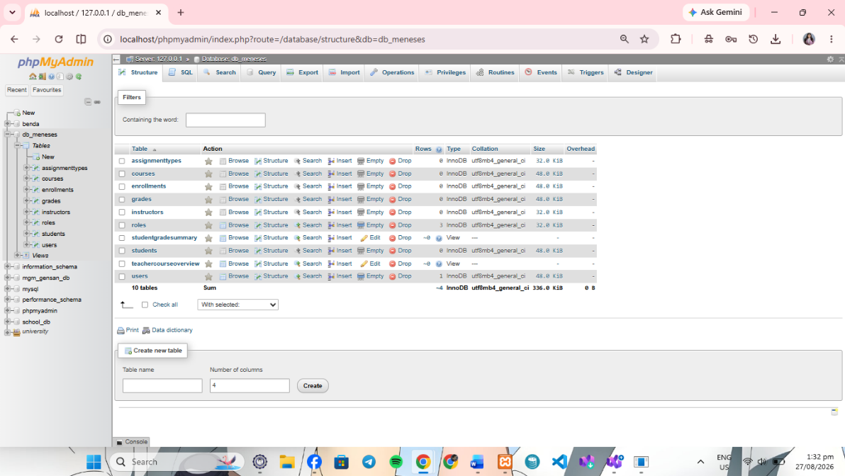

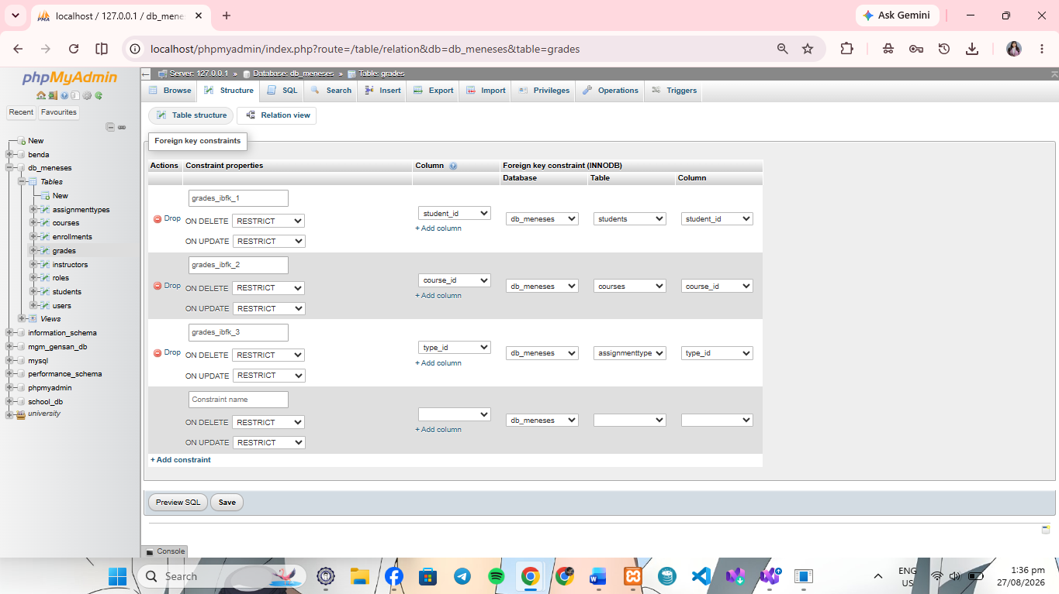

- Screenshot of Updated Database EER Diagram
  - The diagram must now include the AssignmentTypes and Grades tables, clearly showing:
    - The many-to-one relationships from Grades to Students, Courses, and AssignmentTypes.
    - The composite primary key in the Grades table.
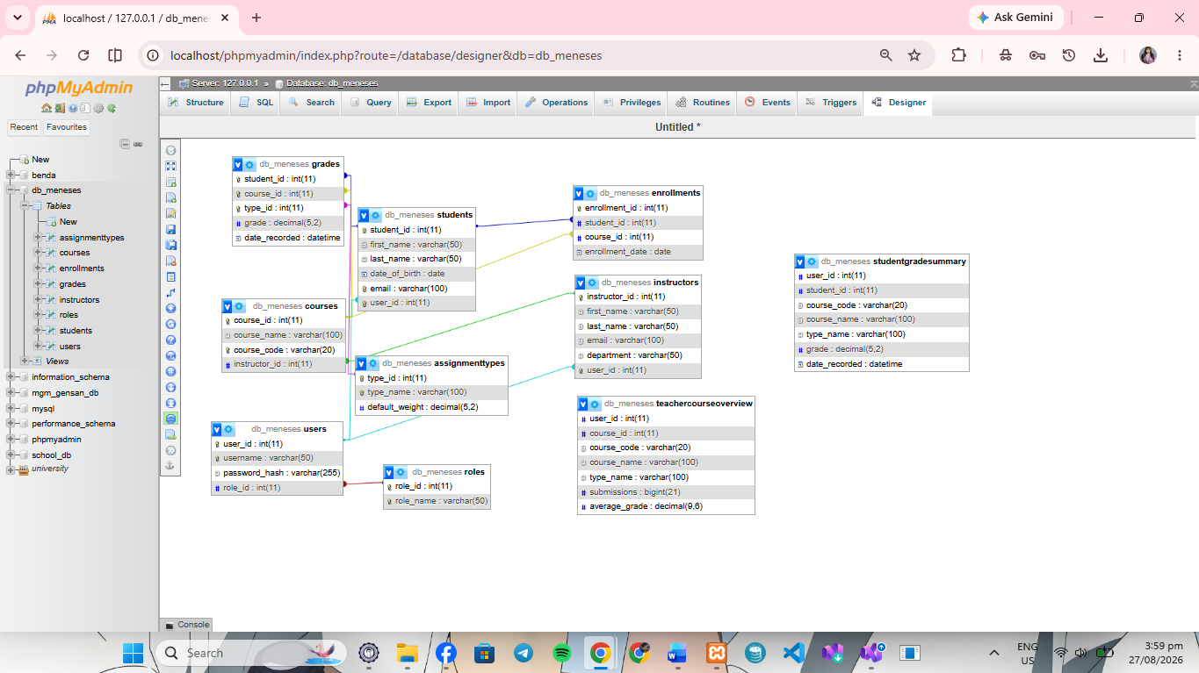

- Screenshots of Enhanced VB.NET Application
  - The new Teacher Dashboard showing the course overview and the interface for entering a grade.
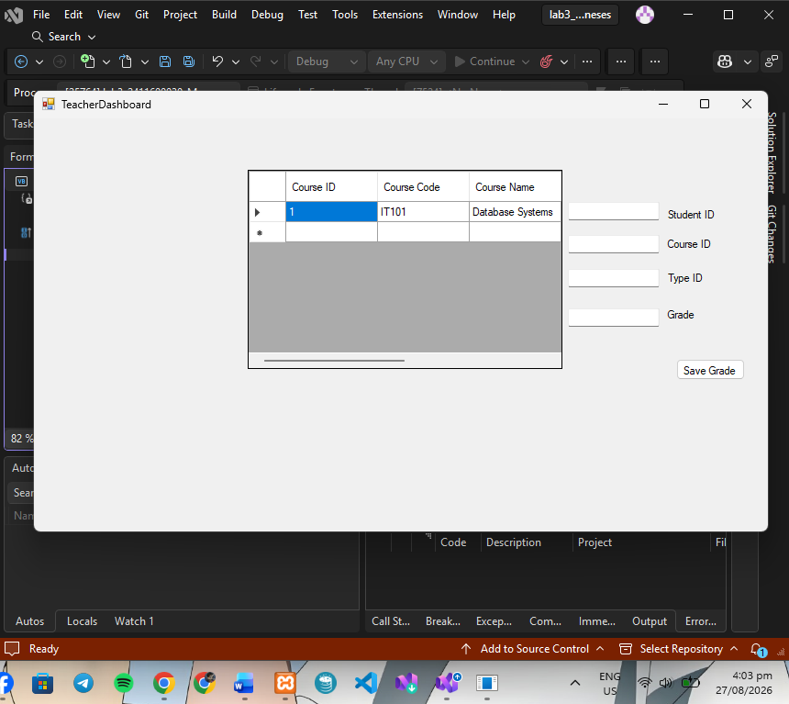

  - The new Student Dashboard showing the student's personal grade summary and course averages.
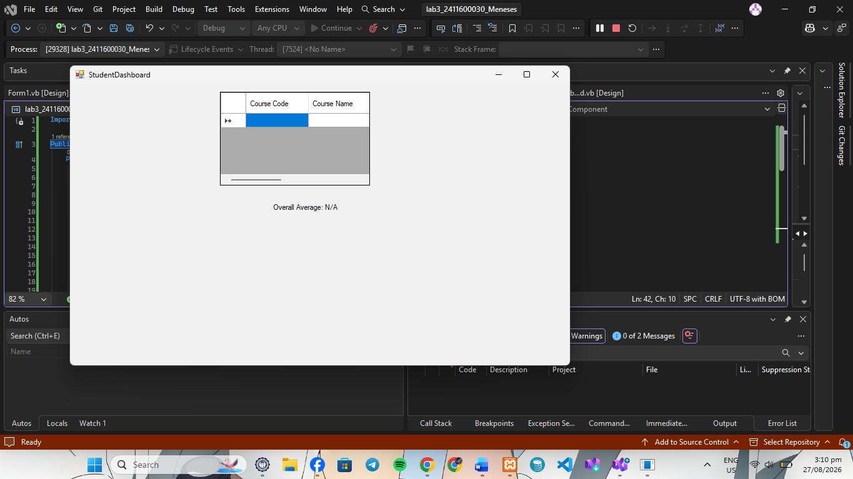

  - The enhanced Admin Form showing the management interface for AssignmentTypes.
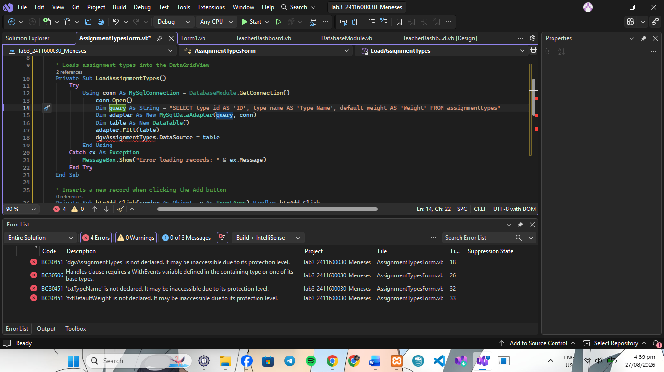

Conclusion
This laboratory exercise helped demonstrate how a database can be made more organized, accurate, and secure through data integrity rules, grade management, database views, and role-based dashboards. By using primary keys, foreign keys, unique constraints, and CHECK constraints, incorrect or duplicate data can be prevented. The use of database views also makes it easier for students and teachers to access the information they need without using complicated queries. Finally, the VB.NET dashboards provide different functions for students, teachers, and administrators based on their roles. Overall, this exercise shows how a properly designed database and application can make managing student grades more reliable, efficient, and easier to use.

